24 March 2010
Well, not much time to write today as I sit writing lesson plans for the BBC...

But coming soon are a few new pages about the Nooruz trip to Shimkent and Turkestan.

For now, here's my latest crazy idea. A squeeze box. Will annoy the neighbours no doubt. Will have to play it quietly :)

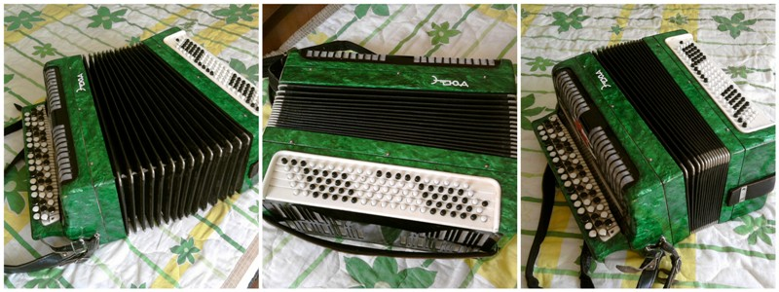

20 March 2010
Periods of writer’s block tend to follow creative periods. I guess this is normal, however, surprisingly neither tally with periods of eventfulness. The period since the last blogge has presented numerous issues any one of which a writer worth his or her pixels would have lapped up with feline glee. I just couldn’t get my arse on a chair for long enough to write it.

In journalistic form, and below, therefore, is today’s blogge...

Nooruz is upon us and a group of teachers are going to a Kazakh city called Shimkent to soak up the atmosphere. The Islamic festival marks the beginning of the New Year and is characterised by festivities of considerable energy and duration. Stand by for a few new pages here.

But we almost couldn’t go. Public holidays here are not to be relied on and advanced planning is almost impossible as decisions made as to national days off are made at the top level a matter of days before they happen. Or don’t happen. Last year we had a day off cancelled two days beforehand which inconvenienced a number of staff who had booked time away and had to restructure their entire lives for a few days. This time it happened in reverse, we were set up for a single day, fearing this as worst case so didn’t book a long trip, as it happened we could have stayed longer.

I’m now not teaching for a week. When the Nooruz break ends I will set sail immediately for the airport and a trip to Astana where I will attempt to keep a host of people speaking for less than 14 minutes each. Yes, it’s the oral exams again. I’m mainly going for the trip, although the speaking exams are actually quite fun sometimes too.

Skiing may be over now, the rains came and so too now has the Spring and there is no snow left in the city. Out in the mountains there will still be a covering and a few more weeks are guaranteed, but I won’t be able to go this week. As for next, it’ll mean setting off late. Last week we arrived late and after sitting in traffic for an hour reached the slopes to find hoardes of people and only one ski lift in operation. We did three descents, and I got that feeling coming down the last time that it was my last of the season. On that basis, going back will now not fit with my energy as I look to find other things to do on Sundays. I may join the new Almaty Hash House Harriers. If I can bear to speak English with anybody.

Judo is coming along OK and I have finally remembered some of the old faithful techniques. It’s consequently become more fun and also less gruelling. But in stark contrast to the judo years of my youth I have found powerful inspiration in some of the judo videos on Youtube. I tried to put them on my phone so I could watch more but the format was unsupported. I won’t waste my time wishing I had taken it more seriously in my younger days, instead will get to it now.

And now, once again, we will celebrate the best football victory since 2008 and 2006 with a small but meaningful photographic collage.

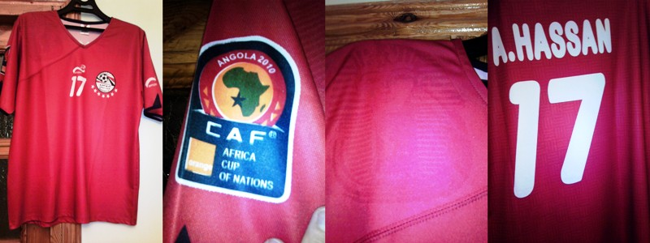

Thank you, Nasra for sending this, and for your constant kindness.

11 March 2010
For three days my apartment building and its car park have been a hive of activity, full of the nicest people who’ve been only too happy to give me time of day, or night. I haven’t got too involved but the offerings of food and chat from people with plenty of other things to do have touched me. Add to this the fact that one of the most famous Brits of recent decades has turned up and similarly had time for me, albeit not extensively, and it’s made for a fascinating few days.

But they’ve gone now. They didn’t even leave a mess.

For what it’s worth, the film is called Liquidator and I understand it’s a Kazakh language film which will therefore not likely hit silver screens too far afield, but the presence of Vinny Jones and Danny Glover could perk up sales in other box offices. Who knows, as you are all aware Kazakhstan is without doubt the best country in the world and is therefore capable of making a decent picture. Watch this space (or the screen shaped space in front of you in the cinema) and keep a few quid aside for tickets.

Yet I get a nagging sense of scepticism from people exiled outside Kaz (where exiled = not lucky enough to be here) that said Mr Jones did not in fact turn up on my car park this week. I have to admit, it seems implausible, yes. And no, I can’t prove it. I did ask him about a photo but he was working, albeit on a break. I think respect was due and I nodded on his saying that we could get to it later on. When they finished filming he shot down the stairs not looking the most approachable of bunnies. I left it. All I can offer now is a few shots of the set.

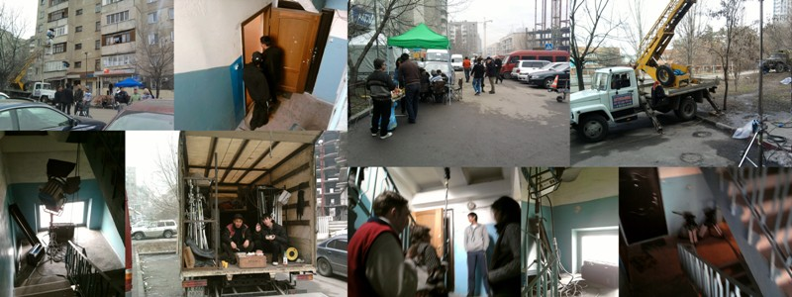

Notice the holes in the door, Pic 2. They drilled them to represent bullet holes. In the picture with four people on the stairs, they were preparing to film Vinny Jones scrapping with a hit man. I saw the scene, it seemed a bit wooden but they reshot it several times after I left.

Rumour has it that Vinny Jones doesn’t speak in the film. He has a bit part which I believe took three days to film. Perhaps as well. I don’t think Cockney and Kazakh would make a fantastic blend.

I nearly hit a 180 on the same day. Ooh, this is close to the wire. Any closer and it’d bounce out. But any closer than that and we’d be into Phil Taylor territory. I wonder if he’d come over to Kazakhstan for anything.



9 March 2010
It flatters me that I am able to sustain a blogge, a Latest News page, in the absence in most cases of anything really newsworthy. Face it, I don’t live a very happening life on many levels, and nor is Almaty the most happening place in the world. In many ways it makes us a nest, a cosy little space to snuggle up in while others make headlines in far away places.

This partly explains the confusion of today’s events which have left me yet rather a tad befuddled.

This morning was set to be like any other. The only change was the fact I could see the mountains, a feat not usually attainable given the noxious smog that obscures them. On leaving for my run I was interested to note a film crew setting up in a third floor flat and had to sidle gingerly past them. I assumed it was for a run of the mill Kazakh tug-of-love TV drama and saw nothing to change my mind when I returned a few hours later.

Shortly after my intense fear of lifts left me short of options for leaving the building, so I tiptoed down the stairs and almost dropped my bag of rubbish into the middle of the set, much to the annoyance of the crew although not the actress who I should add was very pretty. But I still thought nothing of it, and they were very nice to me anyway.

I came a different way back from the shop. In the car park were scores of people somehow involved with this film. (Apparently it’s a cinema job, not for TV.) One of them looked like Vinny Jones, but I didn’t look back, and nor did I even bother to say the line ,’nah, it couldn’t be!’ I mean, it couldn’t have been.

It was.

Quite what got him involved with a Kazakh film I know not. But that couldn’t be my point, could it? You just don’t expect to wake up to a film crew downstairs and then find that one of the stars is a British household name.

I wouldn’t have gone so far out of my way to meet him, and I’m sure he wouldn’t mind that, but as I was passing the set we met on the stairs, and I chanced a few words. No meaningless platitudes, I merely said he might meet more interesting people than me in Kazakhstan, but very few other Welshmen. Ironically, neither I nor he are pure Welsh, and I think his ironic smile reaffirmed this. Filming is set to continue tomorrow, so as some of you will currently be wondering if I have lost my marbles or something, I’ll see what progress I can make towards getting a photograph.

It will look like this...

here

... but will prove my sanity.

Other news is that SMS shorthand still annoys me so don’t write to me in it please, Western Union branches sometimes don’t have any money, and they have pressed the slopes at Chimbulak. It was great skiing yesterday after weeks of bumps on the piste. I remarked that I felt the poor surface had made me a better skier but this met with no agreement. I can accept that technically I will not have benefitted from it, but add that the removal of such a hindrance made the new slope seem so much easier. Athletes sometimes train with weights and remove them just before the race. This is not solely to improve their ability but to make them feel so much lighter when they finally race. Finding a flat slope on Sunday allowed me to move a lot faster without loss of control. Only downside, there were just so many people higher up the slopes, especially where at the confluence of two tributaries emanating from the top of two different ski lifts. Skiers, not rivers.

4 March 2010
Today’s blogge is given as a personal opinion and should not be taken as medical advice. If you have a variety of lurgy or feel like poo, go to a registered medical practitioner.

At long last I am able to say a few sniffly words of my own. My hitherto unending wait for a cold has finally ended and I have spent the day sniffling, considering not going to judo tomorrow and hoping my cold sore will not spread off the lip (delaying healing by about ten days).

It’s not that I’ve wanted a cold but I am afflicted by the enlightened opinion that colds are actually good for us. I haven’t been brainwashed by the pharmo giants who make billions out of people who use pills and medicines as frontline treatment for conditions which are quite literally natural cleansing functions of a healthy body trying to keep itself fully functional.

Let me explain. When we get a cold it is the action of the body trying to rebalance (as is any disease, to be frank). The fundamental reason for the pattern of symptoms a cold gives us is to eliminate excess toxins that have accumulated and which threaten to undermine the body’s natural functionality. Most of it comes out of your nose, face it, but there are a host of other less quantifiable processes which have the same basic intention. To retain the purity of the human organism.

We don’t catch colds, rather become susceptible to them at changes of season or climate when the body realises it needs more energy. We often live together, eat together and so eat badly together. It follows we ‘get colds’ together. The fact I have one now, after some years, is because my body is tired after a winter living in a polluted city during which I have done little exercise. As spring approaches I need to get my energy moving, but the toxic accumulation is an impediment to the natural springtime upward movement. Spring is when nature regenerates and emerges from its winter hibernation. How can we rise up and flourish with excess baggage in tow?

The striking thing is, a cold is a natural protection against more serious conditions. Where a toxic burden becomes unsustainable it is localised by the body in an attempt to keep the system working. If it is not then dealt with it spreads as secondaries and poisons the system. Modern approaches to treating this common condition are improving and research into the area is essential, but at the level we individuals are in control of, what goes in doesn’t always come out. And while it stays in it retains the potential to cause trouble.

There is one FAQ... why does a cold feel so bad then? Simple, it takes a lot of energy to acutely detox. If you are imbalanced (as we all are) or have any energetic deficiency you will experience a ‘downturn’ in normal body activity while the cold takes its turn. Those who don’t get colds can take their pick from this list... a) you have no toxic overload because either you eat, think and drink totally purely and/or your body deals with it through daily elimination, b) you have lost the ability to detox in this way, or c) you are dynamic enough to detox without any noticeable impact on the functionality of your body.

You know, ‘colds’ happen on a mental level too, although they are more difficult to pinpoint. We accumulate mental debris in the same way and to keep the mind pure, relatively speaking, it has to be shifted. Short periods of unexplained depression, hyperactive creativity or other personality changes can be the ‘mental runny nose’ taking effect.

Fasting, recommended by many religions, is a basic and effective way to detox. It is much misunderstood and while I am NOT recommending it, I do it thoughtfully on occasion and ALWAYS feel better afterwards. Juice fasting is the best. Just strap a can of V5 to a Virgin West Coast and let Branson do the rest.

I fasted once and drank mainly beetroot juice. I won’t tell you what happened after two days :)

What we need is a berk detox. The whole world needs to drink carrot juice and eat sunflower seeds for a few days and maybe after a global trip to the toilet we will be free of Liverpool supporters, TEFL teachers who think word searches are a good use of their adult students’ classroom time, and British Post Office counter staff.

Come to think of it, the first and third category are running on borrowed time as it is.

Judo tomorrow? Probably not. I think keep warm and rest will be a better strategy. I will also listen to Donald Simone and think about learning more vocabbe.

2 March 2010
There’s as wide a range of sensibilities in the classroom as outside it, and we have to be mindful that things in class can be taken the wrong way. It’s always paid me to respect the motto, ‘if in doubt, leave it out’ but I felt suitably led today to take a risk to the contrary. Because of its respect for modern English grammar and generosity of conditional clauses, the song, Every Time I See You by good old Donald Simone was almost perfect for an Advanced class due to revise that very grammar focus today.

I say almost perfect. Er, I wondered if the lyrics might be a little inappropriate. I suppose this is where it pays to have a closer relationship with your students than many teachers would recommend. Luckily this class are not kids, it’s OK, and the song was OK. The activity was OK, and they were interested to know how I knew a singer songwriter of such talent. Not sure when the Central Asian leg of the world tour starts, but there’ll be plenty of call for tickets, that’s for sure.

I think we are going away for the weekend, a group of us to a Kazakh city called Shimkent. Very Kazakh. New page therefore due on the site. Worth missing skiing for? Hmmm. Close call that. Shimkent is unlike Almaty and I have oft wanted to visit. Watch this space.

Or you can watch TV if you like, you probably get the update by email. I’ll keep you informed.

For now, I leave you with a video which will hopefully show you that judo is not all just two people tugging at each other’s jackets. If anything published to inspire myself, but if life is for sharing here you go.

1 March 2010
Not a lot of content, but I had to share pics of my new dartboard, and, although I haven't quite reached 180 territory yet, I did land a neat 140 last night, seen here on the right. Very close to the maximum, I can be pleased with my early exploits, although you can also tell from the location of the dartholes that I'm a bit wayward and am yet to find my form.

